DARREN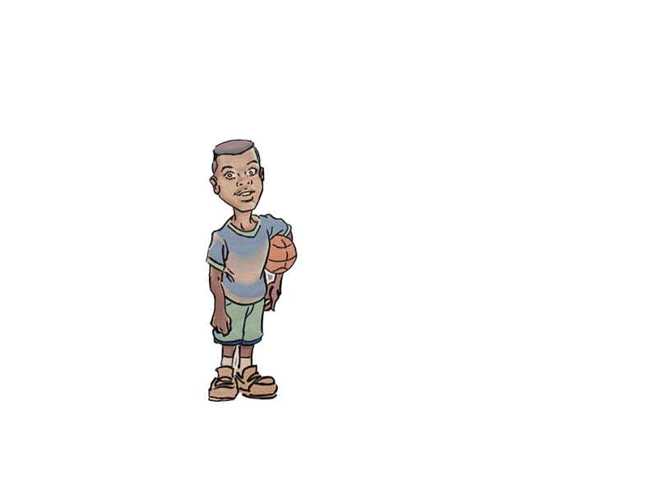

Darren is the Knuck Knucks that loves to play basketball. Darren, Jonz, is the son of Padoc and Lutricia. Darren is the tactical brain behind the Knuck Knucks crew. With a sharp mind and a relentless drive, Darren is always two steps ahead, carefully crafting the plans that lead his team to victory during their missions. His incredible super speed allows him to move faster than the eye can track, and his super strength makes him a powerhouse in any fight.

Off the battlefield Darren is a dedicated basketball, short in statue, Darren dreams of being a NBA MVP basketball star. He trains daily, blending his athletic talent with his strategic thinking to dominate the court just as he does in combat. Darren can always be seen with BB, his basketball. Darren has the ability to jump over the highest buildings. Calm under pressure and fiercely loyal to his team, Darren is the glue that keeps the Knuck Knucks sharp, focused, and always ready for action.

