Name: Flip
Role: The Musician of the Knuck Knucks
Special Abilities: Time-Freezing Chords, Sound Wave
Manipulation
Signature Gear: Custom Power Guitar, Stylish Glasses

Flip is the rhythm and soul of the Knuck Knucks. A laid-back genius with a sharp ear for harmony, Flip dreams of becoming the #1 guitar player in the world. Music is more than a passion – it’s his power. With every strum of his guitar, Flip can bend reality. His special cords can freeze time or pause a moment, giving the team a crucial edge when things get intense.
Using the vibrations from his guitar strings, Flip is can alter sound waves creating sonic shields, shockwaves, or even confusion illusions. His music can calm chaos – or stir it up, depending on the mission.
With his ever- present glasses and a cool, unshakable vibe Flip is the heart of the crew. When he’s not on a mission, he’s writing new riffs or practicing solos that just might change the world.

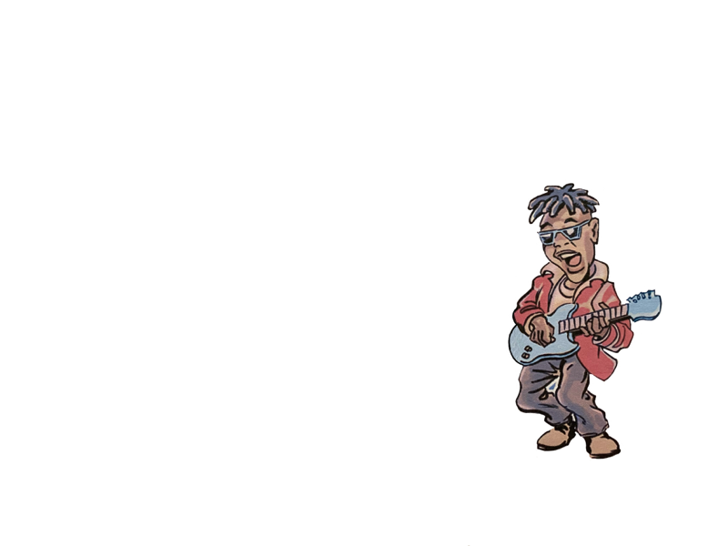
FLIP is the musician and comic of the Knuck Knucks. Flip wears glasses and
plays guitar. Flip dreams of becoming the #1 guitar player in the world.
FLIP, Artu, is also the son of Padco and Lutricia, Flip has the ability to produce sounds and
make music that can be heard over the entire universe. Through the sound vibration of Flip’s
guitar he is able to hit universal cords that can stop or freeze time.
Flip has super human powers of strength.

